Annexure No. SA/14
School of Aeronautics (Neemrana)
I-04, RIICO Industrial Area, Neemrana, Dist. Alwar, Rajasthan
INTERNAL ASSESSMENT EXAMINATION THEORY
Examination: IAE-1 Date: 28/10/18

Subject: Aircraft Structure-II Batch: 10 & 11

Faculty Name: Mr. Bipin Dwivedi Semester: VI

(Attempt any four questions. All questions carry equal marks.)
Total No. of Questions: 06 Total Marks: 30

- Find the moment of inertia about the principle axis for the given section in the figure
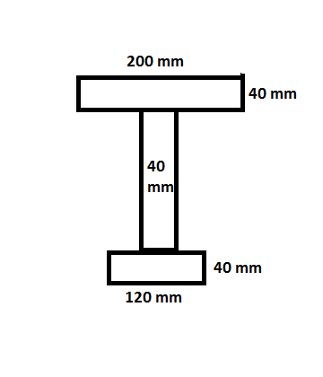

- Derive the position of the principal axis from the centroidal axis $\overline{X}$ and $\overline{Y}$ for an unsymmetrical section.

- Derive the relation $\frac{M}{I}=\frac{σ}{Y}=\frac{E}{R}$ for symmetric bending where, M is bending moment, I is moment of inertia, σ is bending stress, Y is the position of stress from centroidal axis and E is Young’s Modulus

- Find the position of principal axis from centroidal axis $\overline{X}$ and $\overline{Y}$ for the given fig.
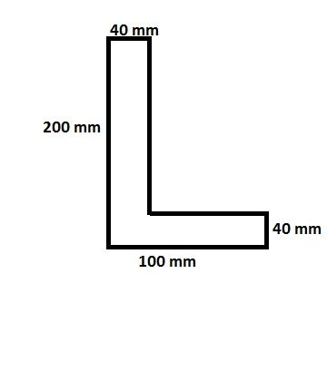
- Find the position of neutral axis from principal axis for unsymmetrical section.

- Calculate the bending stress at a given point A for the section shown in the figure.
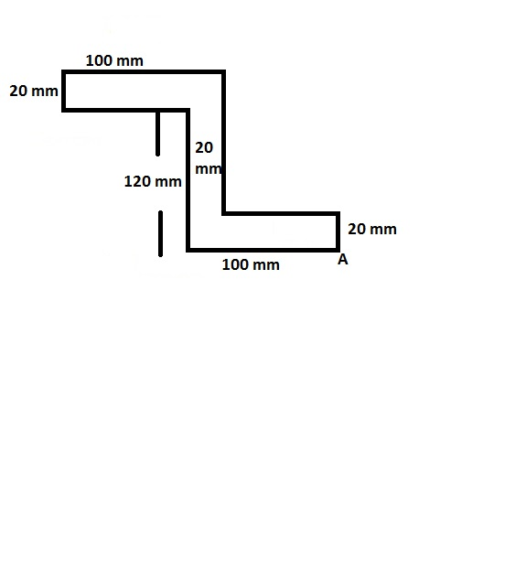
THE END OF THE QUESTION PAPER

